1-CSS

🎨 What is CSS?
# Source: AI Source: Provided by: [Data Path: Persons Table -> ID Column: 1, Name_En Column: Motasem Essam] -> From: [Chatgpt (GPT‑5 Mini)] on [1/26/2026]
CSS stands for Cascading Style Sheets.
It is a style sheet language used to describe the appearance and layout of HTML elements on a web page.

🧠 In Simple Terms:
# Source: AI Source: Provided by: [Data Path: Persons Table -> ID Column: 1, Name_En Column: Motasem Essam] -> From: [Chatgpt (GPT‑5 Mini)] on [1/26/2026]
HTML defines what content appears on the page.
CSS defines how it should look — colors, fonts, spacing, layout, animations, etc.

📄 Example: HTML + CSS
# Source: AI Source: Provided by: [Data Path: Persons Table -> ID Column: 1, Name_En Column: Motasem Essam] -> From: [Chatgpt (GPT‑5 Mini)] on [1/26/2026]
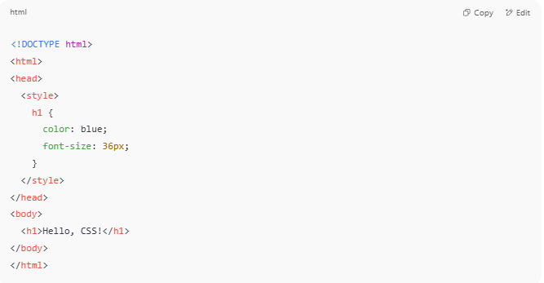
<!DOCTYPE html>
<html>
<head>
<style>
h1 {
color: blue;
font-size: 36px;
}
</style>
</head>
<body>
<h1>Hello, CSS!</h1>
</body>
</html>

✅ The heading Hello, CSS! appears in blue and large font

🔧 CSS Syntax
# Source: AI Source: Provided by: [Data Path: Persons Table -> ID Column: 1, Name_En Column: Motasem Essam] -> From: [Chatgpt (GPT‑5 Mini)] on [1/26/2026]
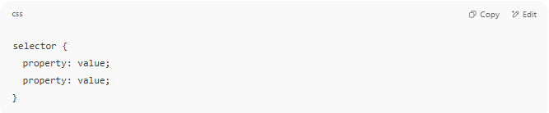
selector {
property: value;
property: value;
}

Example:
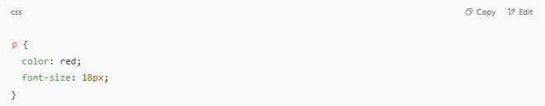
p {
color: red;
font-size: 18px;
}

✅ Targets all <p> (paragraphs), making them red and 18px

🎯 Types of CSS
# Source: AI Source: Provided by: [Data Path: Persons Table -> ID Column: 1, Name_En Column: Motasem Essam] -> From: [Chatgpt (GPT‑5 Mini)] on [1/26/2026]
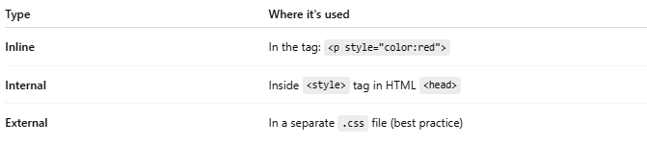
Type | Where it's used
Inline | In the tag: <p style="color:red">
Internal | Inside <style> tag in HTML <head>
External | In a separate .css file (best practice)

💄 What CSS Can Style
# Source: AI Source: Provided by: [Data Path: Persons Table -> ID Column: 1, Name_En Column: Motasem Essam] -> From: [Chatgpt (GPT‑5 Mini)] on [1/26/2026]
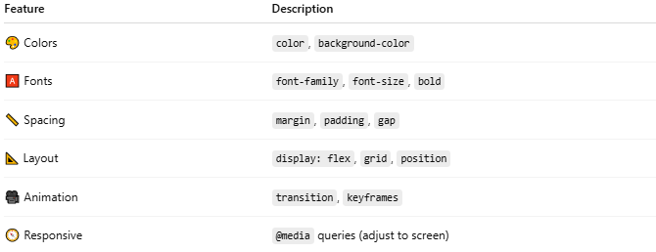

Feature | Description
🎨 Colors | color, background-color
🅰️ Fonts | font-family, font-size, bold
📏 Spacing | margin, padding, gap
📐 Layout | display: flex, grid, position
🎥 Animation | transition, keyframes
🧭 Responsive | @media queries (adjust to screen)

🧩 Example: Styling a Button
# Source: AI Source: Provided by: [Data Path: Persons Table -> ID Column: 1, Name_En Column: Motasem Essam] -> From: [Chatgpt (GPT‑5 Mini)] on [1/26/2026]
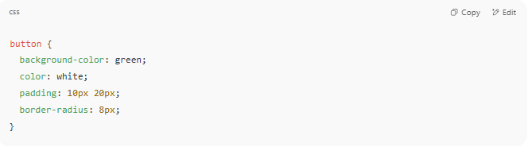
button {
background-color: green;
color: white;
padding: 10px 20px;
border-radius: 8px;
}

✅ Makes a nice modern rounded button

🧠 What Does "Cascading" Mean?
# Source: AI Source: Provided by: [Data Path: Persons Table -> ID Column: 1, Name_En Column: Motasem Essam] -> From: [Chatgpt (GPT‑5 Mini)] on [1/26/2026]
If multiple styles apply to an element, CSS uses rules of priority to decide which one wins — this is the cascade.
Priority Order (highest to lowest):
- Inline styles
- Internal styles (in <style>)
- External stylesheets
- Browser defaults

📌 Summary
# Source: AI Source: Provided by: [Data Path: Persons Table -> ID Column: 1, Name_En Column: Motasem Essam] -> From: [Chatgpt (GPT‑5 Mini)] on [1/26/2026]
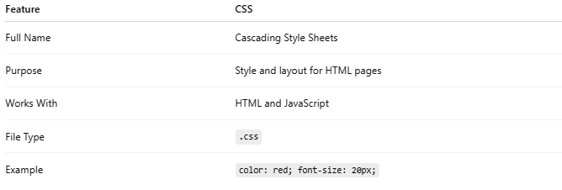

Feature | CSS
Full Name | Cascading Style Sheets
Purpose | Style and layout for HTML pages
Works With | HTML and JavaScript
File Type | .css
Example | color: red; font-size: 20px;

2-SASS

🎨 What is SASS?
# Source: AI Source: Provided by: [Data Path: Persons Table -> ID Column: 1, Name_En Column: Motasem Essam] -> From: [Chatgpt (GPT‑5 Mini)] on [1/26/2026]
SASS stands for Syntactically Awesome Stylesheets.
It is a CSS preprocessor — a powerful extension of CSS that adds features CSS doesn’t support, like:
- Variables
- Nesting
- Mixins
- Functions
- Inheritance
💡 You write SASS code (like programming CSS), and it compiles into standard CSS that browsers can understand.

🔧 Why Use SASS?
# Source: AI Source: Provided by: [Data Path: Persons Table -> ID Column: 1, Name_En Column: Motasem Essam] -> From: [Chatgpt (GPT‑5 Mini)] on [1/26/2026]
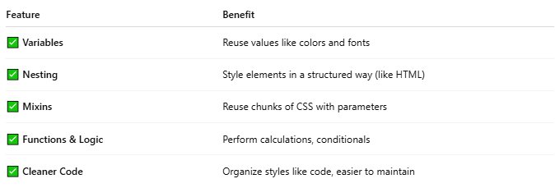

Feature | Benefit
✅ Variables | Reuse values like colors and fonts
✅ Nesting | Style elements in a structured way (like HTML)
✅ Mixins | Reuse chunks of CSS with parameters
✅ Functions & Logic | Perform calculations, conditionals
✅ Cleaner Code | Organize styles like code, easier to maintain

🔤 SASS Syntax Options
# Source: AI Source: Provided by: [Data Path: Persons Table -> ID Column: 1, Name_En Column: Motasem Essam] -> From: [Chatgpt (GPT‑5 Mini)] on [1/26/2026]
There are two syntaxes:
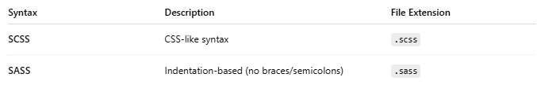
Syntax | Description | File Extension
SCSS | CSS-like syntax | .scss
SASS | Indentation-based (no braces/semicolons) | .sass
Most people use SCSS since it’s more familiar.

🧪 SCSS Example
# Source: AI Source: Provided by: [Data Path: Persons Table -> ID Column: 1, Name_En Column: Motasem Essam] -> From: [Chatgpt (GPT‑5 Mini)] on [1/26/2026]
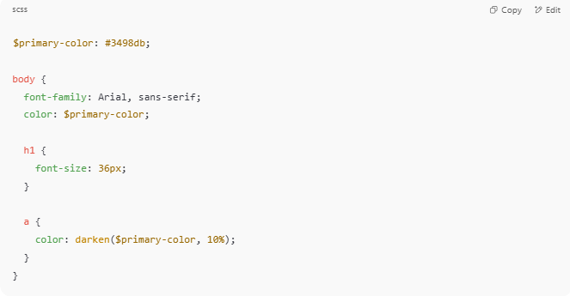
$primary-color: #3498db;

body {
font-family: Arial, sans-serif;
color: $primary-color;

h1 {
font-size: 36px;
}

a {
color: darken($primary-color, 10%);
}
}

🔁 Compiles into standard CSS:
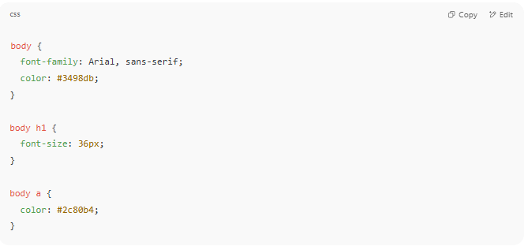
body {
font-family: Arial, sans-serif;
color: #3498db;
}

body h1 {
font-size: 36px;
}

body a {
color: #2c80b4;
}

🛠️ How SASS Works
# Source: AI Source: Provided by: [Data Path: Persons Table -> ID Column: 1, Name_En Column: Motasem Essam] -> From: [Chatgpt (GPT‑5 Mini)] on [1/26/2026]
- You write .scss or .sass files
- A SASS compiler (like sass CLI or build tool) converts it to .css
- The browser loads the final CSS file

🚀 Tools to Use SASS
# Source: AI Source: Provided by: [Data Path: Persons Table -> ID Column: 1, Name_En Column: Motasem Essam] -> From: [Chatgpt (GPT‑5 Mini)] on [1/26/2026]
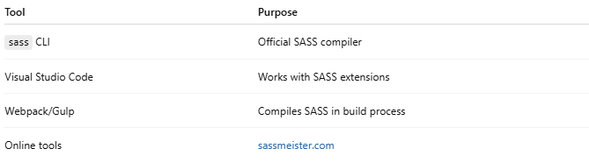

Tool | Purpose
sass CLI | Official SASS compiler
Visual Studio Code | Works with SASS extensions
Webpack/Gulp | Compiles SASS in build process
Online tools | sassmeister.com

📌 Summary
# Source: AI Source: Provided by: [Data Path: Persons Table -> ID Column: 1, Name_En Column: Motasem Essam] -> From: [Chatgpt (GPT‑5 Mini)] on [1/26/2026]
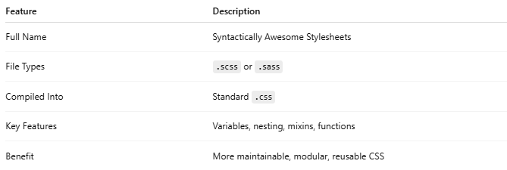

Feature | Description
Full Name | Syntactically Awesome Stylesheets
File Types | .scss or .sass
Compiled Into | Standard .css
Key Features | Variables, nesting, mixins, functions
Benefit | More maintainable, modular, reusable CSS

3-LESS

🎨 What is LESS?
# Source: AI Source: Provided by: [Data Path: Persons Table -> ID Column: 1, Name_En Column: Motasem Essam] -> From: [Chatgpt (GPT‑5 Mini)] on [1/26/2026]
LESS stands for Leaner Style Sheets.
It is a CSS preprocessor — just like SASS — that extends standard CSS by adding features such as:
- Variables
- Nesting
- Mixins
- Functions
- Operations
💡 You write .less code → it compiles into regular .css that browsers can understand.

🧠 In Simple Terms:
# Source: AI Source: Provided by: [Data Path: Persons Table -> ID Column: 1, Name_En Column: Motasem Essam] -> From: [Chatgpt (GPT‑5 Mini)] on [1/26/2026]
LESS makes writing and maintaining CSS easier, shorter, and more powerful.

🔧 LESS Features (with Examples)

1. ✅ Variables
# Source: AI Source: Provided by: [Data Path: Persons Table -> ID Column: 1, Name_En Column: Motasem Essam] -> From: [Chatgpt (GPT‑5 Mini)] on [1/26/2026]
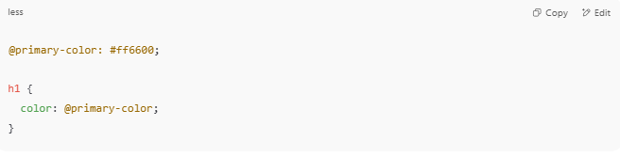
@primary-color: #ff6600;

h1 {
color: @primary-color;
}

2. ✅ Nesting
# Source: AI Source: Provided by: [Data Path: Persons Table -> ID Column: 1, Name_En Column: Motasem Essam] -> From: [Chatgpt (GPT‑5 Mini)] on [1/26/2026]
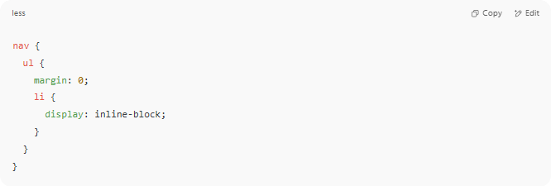
nav {
ul {
margin: 0;
li {
display: inline-block;
}
}
}

3. ✅ Mixins (Reusable rules)
# Source: AI Source: Provided by: [Data Path: Persons Table -> ID Column: 1, Name_En Column: Motasem Essam] -> From: [Chatgpt (GPT‑5 Mini)] on [1/26/2026]
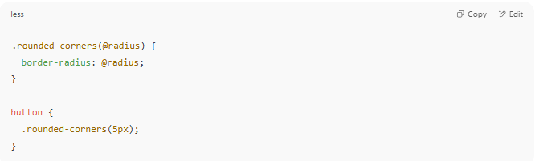
.rounded-corners(@radius) {
border-radius: @radius;
}

button {
.rounded-corners(5px);
}

4. ✅ Math & Functions
# Source: AI Source: Provided by: [Data Path: Persons Table -> ID Column: 1, Name_En Column: Motasem Essam] -> From: [Chatgpt (GPT‑5 Mini)] on [1/26/2026]
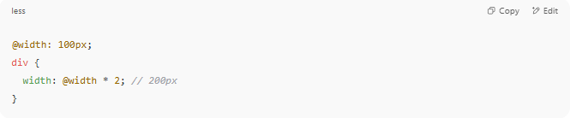
@width: 100px;
div {
width: @width * 2; // 200px
}

🔄 LESS vs CSS
# Source: AI Source: Provided by: [Data Path: Persons Table -> ID Column: 1, Name_En Column: Motasem Essam] -> From: [Chatgpt (GPT‑5 Mini)] on [1/26/2026]
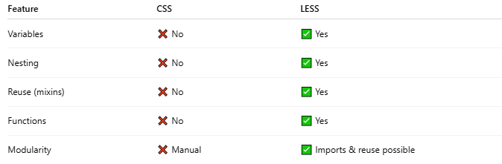

Feature | CSS | LESS
Variables | ❌ No | ✅ Yes
Nesting | ❌ No | ✅ Yes
Reuse (mixins) | ❌ No | ✅ Yes
Functions | ❌ No | ✅ Yes
Modularity | ❌ Manual | ✅ Imports & reuse possible

🛠️ How to Use LESS
# Source: AI Source: Provided by: [Data Path: Persons Table -> ID Column: 1, Name_En Column: Motasem Essam] -> From: [Chatgpt (GPT‑5 Mini)] on [1/26/2026]
- Install LESS compiler (Node.js required
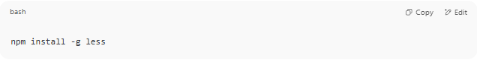
npm install -g less

- Write .less file:
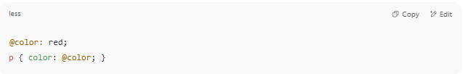
@color: red;
p { color: @color; }

- Compile to .css:
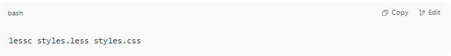
lessc styles.less styles.css

- Link the .css to your HTML as usual.

🔌 Tools That Support LESS
# Source: AI Source: Provided by: [Data Path: Persons Table -> ID Column: 1, Name_En Column: Motasem Essam] -> From: [Chatgpt (GPT‑5 Mini)] on [1/26/2026]
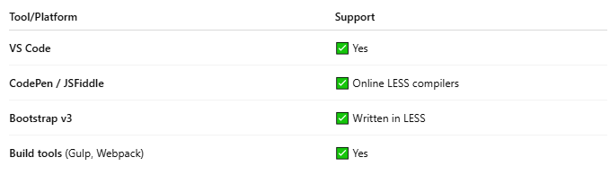

Tool/Platform | Support
VS Code | ✅ Yes
CodePen / JSFiddle | ✅ Online LESS compilers
Bootstrap v3 | ✅ Written in LESS
Build tools (Gulp, Webpack) | ✅ Yes
LESS vs SASS

🧵 LESS vs SASS – What's the Difference?
# Source: AI Source: Provided by: [Data Path: Persons Table -> ID Column: 1, Name_En Column: Motasem Essam] -> From: [Chatgpt (GPT‑5 Mini)] on [1/26/2026]
Both LESS and SASS are CSS preprocessors that add powerful programming features to plain CSS — like variables, nesting, and mixins.
But they differ in:
- Syntax style
- Features
- Community/tools
- Flexibility

🧩 Quick Comparison Table
# Source: AI Source: Provided by: [Data Path: Persons Table -> ID Column: 1, Name_En Column: Motasem Essam] -> From: [Chatgpt (GPT‑5 Mini)] on [1/26/2026]
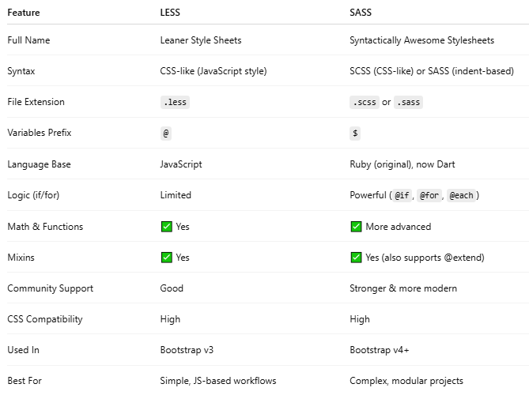

Feature | LESS | SASS
Full Name | Leaner Style Sheets | Syntactically Awesome Stylesheets
Syntax | CSS-like (JavaScript style) | SCSS (CSS-like) or SASS (indent-based)
File Extension | .less | .scss or .sass
Variables Prefix | @ | $
Language Base | JavaScript | Ruby (original), now Dart
Logic (if/for) | Limited | Powerful (@if, @for, @each)
Math & Functions | ✅ Yes | ✅ More advanced
Mixins | ✅ Yes | ✅ Yes (also supports @extend)
Community Support | Good | Stronger & more modern
CSS Compatibility | High | High
Used In | Bootstrap v3 | Bootstrap v4+
Best For | Simple, JS-based workflows | Complex, modular projects

🔧 Syntax Example

✅ Variables
# Source: AI Source: Provided by: [Data Path: Persons Table -> ID Column: 1, Name_En Column: Motasem Essam] -> From: [Chatgpt (GPT‑5 Mini)] on [1/26/2026]
LESS:
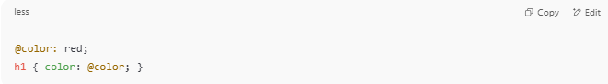
@color: red;
h1 { color: @color; }

SASS/SCSS:
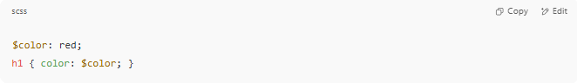
$color: red;
h1 { color: $color; }

✅ Nesting
# Source: AI Source: Provided by: [Data Path: Persons Table -> ID Column: 1, Name_En Column: Motasem Essam] -> From: [Chatgpt (GPT‑5 Mini)] on [1/26/2026]
LESS:
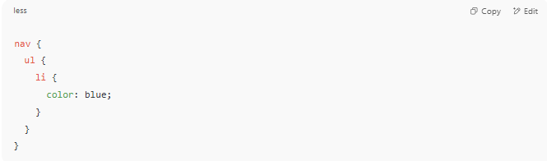
nav {
ul {
li {
color: blue;
}
}
}

SCSS:
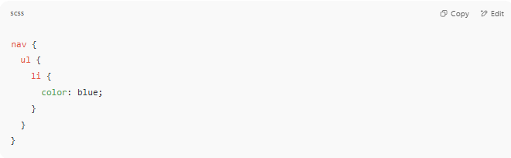
nav {
ul {
li {
color: blue;
}
}
}

✅ Nearly identical syntax here.

✅ Mixins with Parameters
# Source: AI Source: Provided by: [Data Path: Persons Table -> ID Column: 1, Name_En Column: Motasem Essam] -> From: [Chatgpt (GPT‑5 Mini)] on [1/26/2026]
LESS:
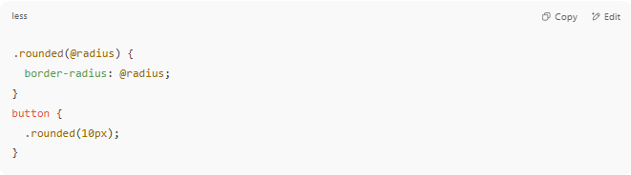
.rounded(@radius) {
border-radius: @radius;
}
button {
.rounded(10px);
}

SCSS:
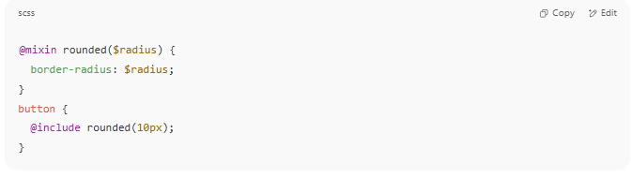
@mixin rounded($radius) {
border-radius: $radius;
}
button {
@include rounded(10px);
}

🧠 Major Differences
# Source: AI Source: Provided by: [Data Path: Persons Table -> ID Column: 1, Name_En Column: Motasem Essam] -> From: [Chatgpt (GPT‑5 Mini)] on [1/26/2026]
1. Control Structures
SASS has full control flow features (@if, @for, @each, @while) — LESS does not.
2. Extend vs Mixins
SASS has both @mixin and @extend. LESS only supports mixins (no extend).
3. Tooling
- LESS is simpler and integrates easily with JS-based tools.
- SASS is more powerful, and widely used in modern frameworks (Bootstrap 4+, Tailwind, Angular, etc.).

✅ Which One Should You Use?
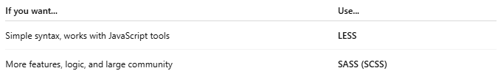

If you want... | Use...
Simple syntax, works with JavaScript tools | LESS
More features, logic, and large community | SASS (SCSS)
⚠️ SASS is more widely adopted in 2024+, especially in professional and large-scale projects.

📌 Summary
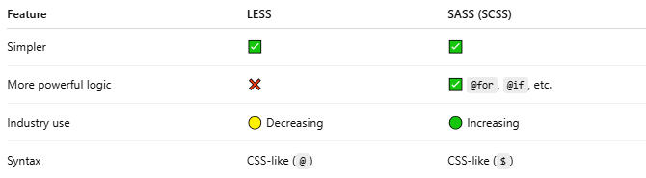
Feature | LESS | SASS (SCSS)
Simpler | ✅ | ✅
More powerful logic | ❌ | ✅ @for, @if, etc.
Industry use | 🟡 Decreasing | 🟢 Increasing
Syntax | CSS-like (@) | CSS-like ($)

📌 Summary
# Source: AI Source: Provided by: [Data Path: Persons Table -> ID Column: 1, Name_En Column: Motasem Essam] -> From: [Chatgpt (GPT‑5 Mini)] on [1/26/2026]
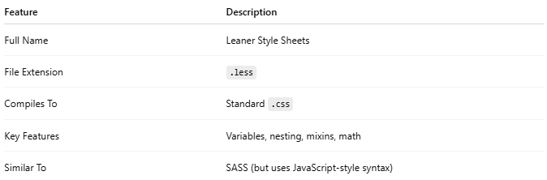

Feature | Description
Full Name | Leaner Style Sheets
File Extension | .less
Compiles To | Standard .css
Key Features | Variables, nesting, mixins, math
Similar To | SASS (but uses JavaScript-style syntax)

